WAVEFORM GENERATOR QUICK REFERENCE (27 WAVES)
ID | Waveform Name | Function Name | Description
0 | Sine | makeSine | Standard sine wave — 127 + 127·sin(2πi/N)
1 | Triangle | makeTriangle | Linear triangle — 2·(i/N)−1 scaled 0–255
2 | Saw Tooth | makeSaw | Rising sawtooth — 255·(i/N)
3 | Square | makeSquare | 50% duty square — (i < N/2) ? 255 : 0
4 | EKG Wave | makeEKG | Heartbeat pulse — P-wave → QRS → T-wave
5 | CRAZY!!! | makeCrazy1 | Harmonic cocktail — sin(x)+sin(2x)/2+…
6 | Stepped | makeSteps | Quantized staircase — floor(i/(N/S))·(255/(S−1))
7 | Double Pulse | makeDoublePulse | Two narrow pulses — at N/4 and 3N/4
8 | Random Noise | makeNoise | Pseudo-random — random(0,255)
9 | Half Rect Sine | makeHalfRect | Half-rectified sine — max(0,sin()) scaled
10 | BLOB!! | makeBlob | Raised cosine bump — 127 + 127·cos(2πi/N)
11 | Bent Saw Tooth | makeBentSaw | Curved saw — 255·(i/N)^k
12 | Shark Fin | makeSharkfin | Fast rise, instant drop — exponential rise
13 | Hyper Sine | makeHyperSine | Clipped sine — clamp(A·sin())
14 | Wobble Pulse | makeWobblePulse | AM pulse — square(x)·(0.5+0.5·sin())
15 | Ripple Saw | makeRippleSaw | Saw + ripple — saw(i)+A·sin(k·2πi/N)
16 | Folded Sine | makeFoldedSine | Wave-folded sine — sin(2.2πi/N) folded
17 | SuperSaw | makeSuperSaw | Detuned saws — Σ detuned saws, normalized
18 | SinFold | makeSinFold | Fold-distorted sine — sin(sin()·G)
19 | PulseSweep | makePulseSweep | Sweeping duty — (i mod P < D(i)) ? 255 : 0
20 | SpiralWave | makeSpiralWave | Phase-rotating sine — sin(x + k·sin(x))
21 | ChaosSpark | makeChaosSpark | Chaotic bursts — logistic map + spikes
22 | Formant | makeFormant | Vocal-like resonance — sin(x)·sin(F1x)·sin(F2x)
23 | BitCrush Saw | makeBitCrushSaw | Bit-reduced saw — (saw >> B) << B
24 | WindowPulse | makeWindowPulse | Windowed pulse — pulse(i)·hann(i)
25 | TentMap | makeTentMap | Chaotic tent function — r·min(x,1−x)
26 | FM Sweep | makeFMSweep | FM-modulated sweep — sin(x + m·sin(fm·x))

Waveform Reference TableN = buffer length, i = sample index (0…N-1), all outputs 0–255.

WIRING DIAGRAM (GRAYSCALE)

Arduino UNO R4 WiFi Connections

Buttons (Using Analog Pins as Digital Inputs)
- A5 → Blue Button
  - Manual Mode / Next Wave Tap to advance/Hold 1 sec, to return to Auto Mode
- A3 → Yellow Button (Middle)
  - Duty Adjust – Tap to adjust/Hold for fast adjust
- A4 → Yellow Button (Right)
  - Duty Adjust + Tap to adjust/Hold for fast adjust
  - Duty Mode Toggle (Double-tap)
All buttons share a common ground bus.

DAC Output
- DAC pin → Output jack / test point
- Ground → Output ground

LED Matrix
- Uses built-in UNO R4 LED matrix
- No external wiring required

Power
- USB-C for power and programming
- 9v UNO power port

BUTTON LAYOUT DIAGRAM

Breadboard Layout (Top-Down, Grayscale)
Code
[ Blue Button ] [ Yellow – ] [ Yellow + / Mode ]
| | |
A5 A3 A4
| | |
--------------------------------------------------- ← Ground Bus

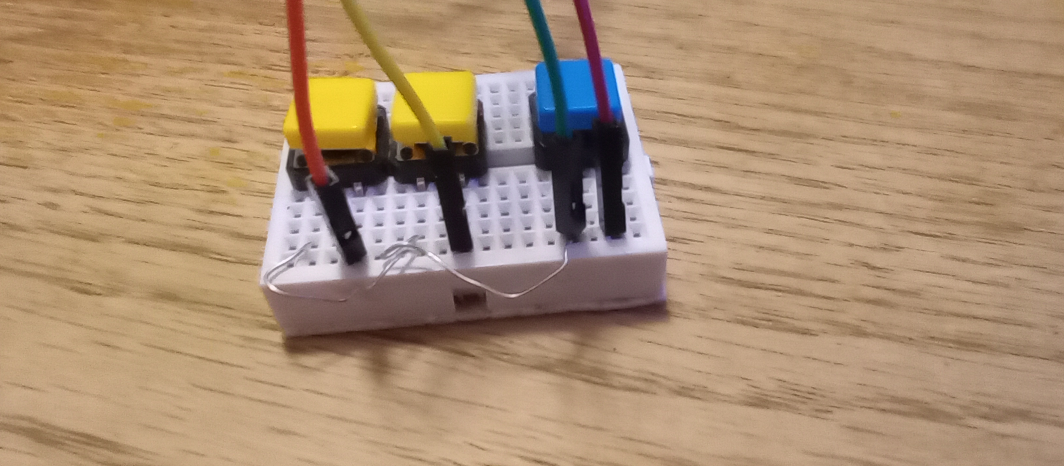
Button detail
- All buttons share the same ground wire
- Each button’s opposite leg goes to its respective UNO pin
- Internal pull-ups enabled (no resistors needed)

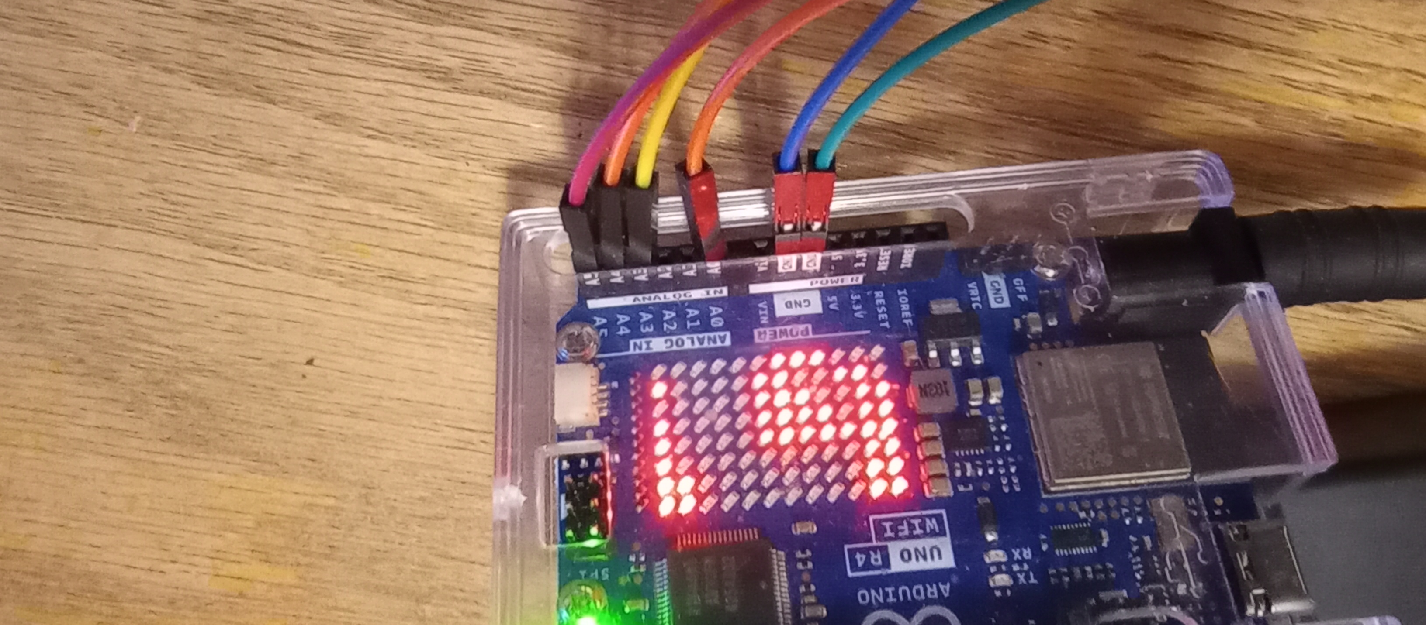
Arduino UNO R4 connections
From left to right
- Green GRND => Button assy. (Blue button ground bus)
- Blue GRND => Oscilloscope ground.
- Orange A0 => DAC output (Oscilloscope probe)
- Yellow A3 => Yellow button. Duty + / Duty toggle
- Orange A4 => Yellow Button. Duty -
- Red A5 => Blue button. Wave advance / automode-manual mode toggle

OPERATION GUIDE

Startup
- Device loads boot message
- Waveform 0 loads automatically
- DAC output begins immediately

Modes

Auto Mode
- Default mode
- Waveform scrolls continuously
- Advvances waveform every 5 sec
- Duty not shown unless duty mode is active

Manual Mode (Blue Button)
- Tap → Next waveform
- Manual mode indicator appears on matrix upper right corner
- Hold 1 sec, to return to Auto Mode

Duty Mode (Right (+) Yellow Button)
- Single tap: Adjust duty% 1 increment
- Double tap: Duty ON/OFF toggle
- Duty ON: Scroll shows “WaveName Duty XX%”
- Duty OFF: Scroll shows only waveform name

Duty Adjust
- Middle Yellow: Duty (–)
- Right Yellow: Duty (+) / Duty ON/OFF toggle
- Hold buttons for fast adjust
- Live duty display appears immediately
- After timeout, scroll returns to combined Wave + Duty text

Scroll Behavior
- Waveform name scrolls continuously
- If duty is active, scroll includes duty percentage
- Live duty display overrides scroll temporarily
- Manual mode and duty mode icons appear in matrix corners

Troubleshooting
- Blinking text: Normal (matrix ignores alpha channel)
- No fade effects: Matrix does not support brightness levels
- Duty not showing: Duty mode must be ON
- Wave changes hide duty: Fixed in latest firmware

NOTES / VERSION
- Project: UNO R4 Waveform Generator
- Hardware: UNO R4 WiFi, LED Matrix, 3-button breadboard
- DAC: 8-bit output
- Firmware: Latest revision with duty-scroll fix
Notes:
- Add new waveforms here
- Add future features
- Space for wiring changes
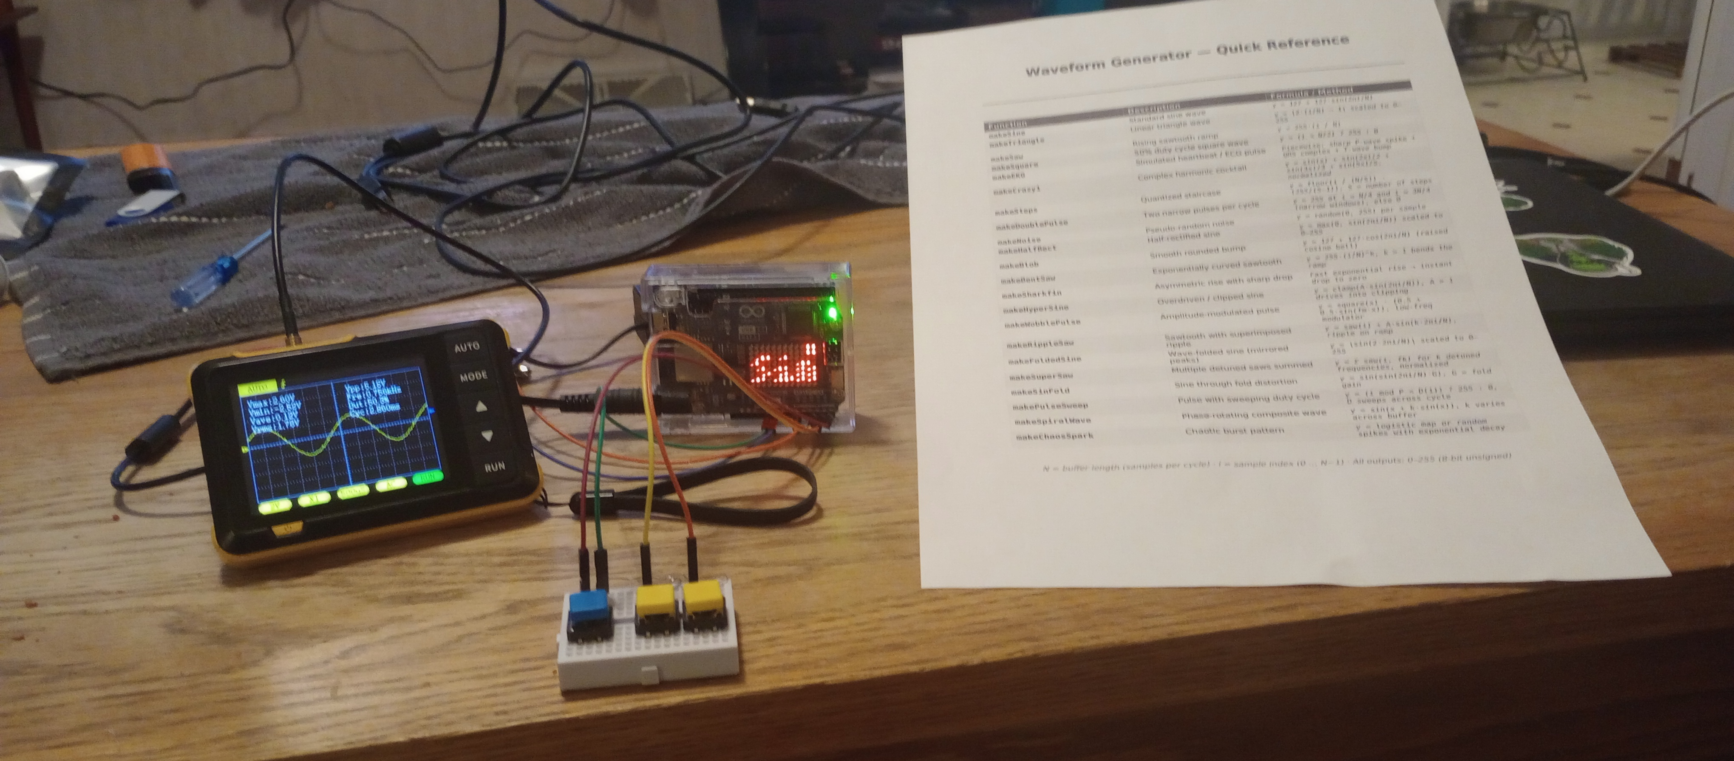
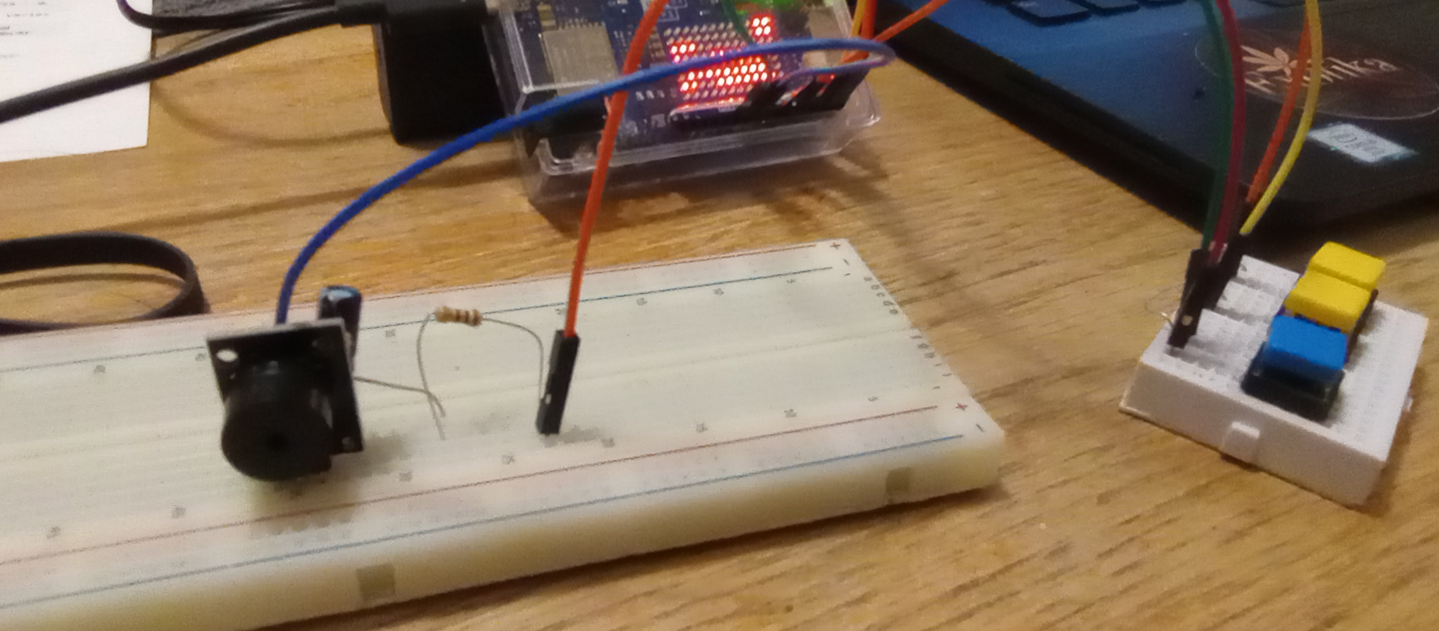
Oscilloscope connected and running!

Optional passive buzzer hookup. (Hear your waveforms!)
You will need a 100 Ω resistor and a 10 µF electrolytic capacitor (50v)
- On 10 µF electrolytic capacitor (50v), connect capacitor (–) side to “S” buzzer leg and (+) side to resistor.
- Connect A0 – DAC output wire to 100 Ω resistor
- GRND wire to – buzzer leg opposit “S” leg.(not the middle leg)
- Kick back, enjoy the sounds!

